Assignment -1

Siva Datta B.,

17EC10010.

**1 (a) and 1(b) :-**

Aim :-

Sampling a sine wave form at different rates (both below and above Nyquist rate and observe the effect of aliasing).

Code :-

clc

clear all

close all

fs=4e3; %sampling rate 12 kHz

f=1e3; %Frequency of sinusoid

nCyl=1e3; %generate five cycles of sinusoid

t=0:1/fs:nCyl*1/f; %time index

x=10*cos(2*pi*f*t)+6*cos(2*2*pi*f*t)+2*cos(4*2*pi*f*t);

n1=64;

n2=128;

n3=256;

y1 = fft(x,n1);

y1 = fftshift(y1);

m1 = abs(y1)/n1;

y2 = fft(x,n2);

y2=fftshift(y2);

m2 = abs(y2)/n2;

y3 = fft(x,n3);

y3=fftshift(y3);

m3 = abs(y3)/n3;

f1 = (-length(y1)/2:length(y1)/2-1)*fs/length(y1);

f2 = (-length(y2)/2:length(y2)/2-1)*fs/length(y2);

f3 = (-length(y3)/2:length(y3)/2-1)*fs/length(y3);

subplot(3,1,1);

stem(f1,m1)

title('DFT with n=64');

xlabel('Freq');

ylabel('Amplitude');

subplot(3,1,2);

stem(f2,m2)

title('DFT with n=128');

xlabel('Freq');

ylabel('Amplitude');

subplot(3,1,3);

stem(f3,m3)

title('DFT with n=256');

xlabel('Freq');

ylabel('Amplitude');

Results :-

At 4kHz:

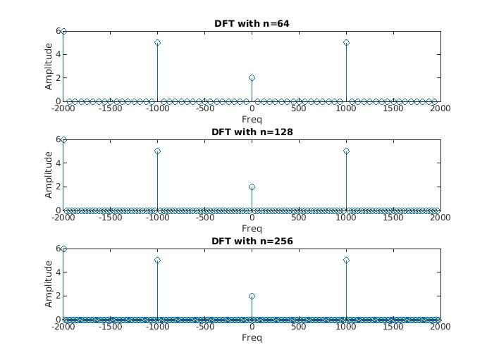

At 5Khz :-

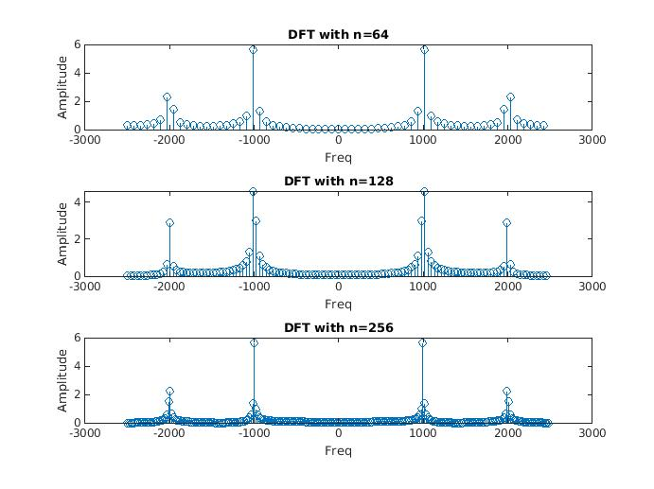

At 8Khz:-

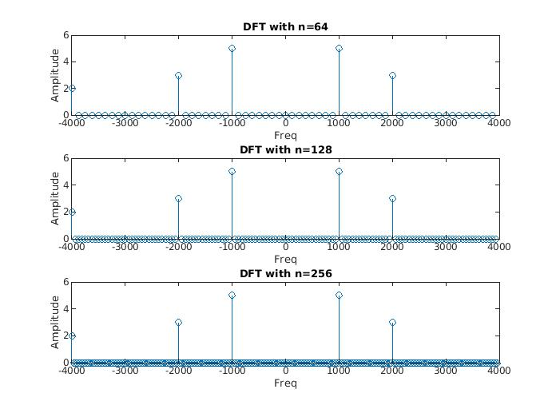

At 12 kHz:

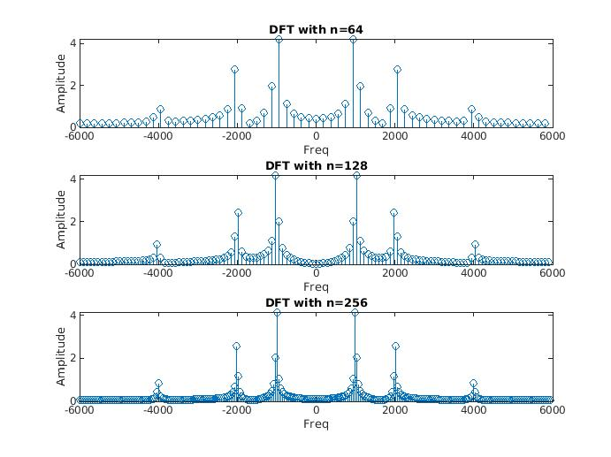

**1 (c) :-**

Aim :-

Sampling a square wave.

Code :-

clc

clear all

close all

fs=20e3;

f=1e3;

nCyl=1000; %generate five cycles of sinusoid

t=0:1/fs:nCyl*1/f; %time index

x=square(2*pi*f*t);

n=256;

%stem(x)

y=fft(x,n);

y=fftshift(y);

m=abs(y)/n;

f = (-length(y)/2:length(y)/2-1)*100/length(y);

stem(f,m)

title('DFT Square');

xlabel('Freq');

ylabel('Amplitude/N');

Results :-

1Khz Square wave:-

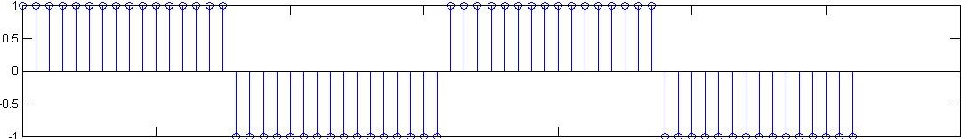

DFT OF square wave with 1 Khz frequency:

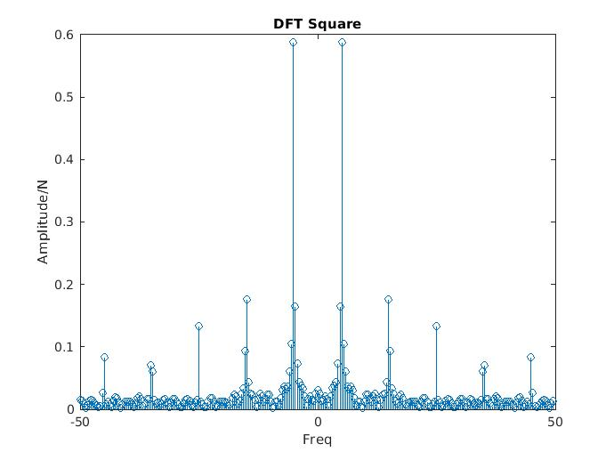

**1 (d) :-**

Aim :-

Interpolation or Upsampling

Code :-

% Interpolation or Upsampling of a over sampled Signal

N = 50; % Number of samples

% Sampling at Fs = 12 KHz

Fs= 12000;

t = 0:1/Fs:N/Fs;

n = 0:1:N;

x = sin(2*pi*4500*t);

figure(1);

stem(n,x);

title('Sin(2*pi*4500*t) sampled at Fs = 12 KHz');

xlabel('Sample');

ylabel('Amplitude');

grid on;

% Sampling at Fs = 24 KHz

Fs1= 24000;

t1 = 0:1/Fs1:N/Fs1;

n1 = 0:1:N;

x1 = sin(2*pi*4500*t1);

figure(2);

stem(n1,x1);

title('Sin(2*pi*4500*t) sampled at Fs = 24 KHz');

xlabel('Sample');

ylabel('Amplitude');

grid on;

% Adding Zero in between two Samples

for i=1:N

y(2*i-1)= x(i);

y(2*i)=0;

end;

a=1:2*N;

% plot after inserting zeros between two samples

figure(3);

stem(a,y);

axis([0 50 -1 1]);

title('Plot after inserting zeros between two samples of above graph');

xlabel('Sample');

ylabel('Amplitude');

grid on;

% Low Pass Filter Design and Inputing the new signal

F = 24000; % Sampling Frequency for

order = 10; % Order of filter

F_cutoff = 6000 / F; % Frequency in Radians

b=fir1(order,F_cutoff);

result=conv(y,b); % Output of the filter

temp=1:2*N+order;

% Ploting the Interpolated Signal

figure(4);

stem(temp,result);

axis([0 50 -0.15 0.15]);

title('Plot of the Interpolated Signal');

xlabel('Sample');

ylabel('Amplitude');

grid on;

% Frequency Response of the Filter

figure(5);

freqz(b,1,512);

title('Frequency Responce of the low pass filter');

grid on;

Results :-

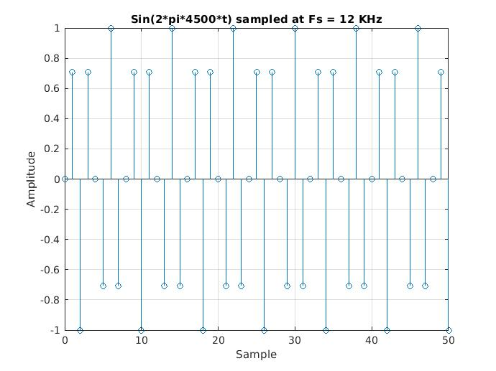

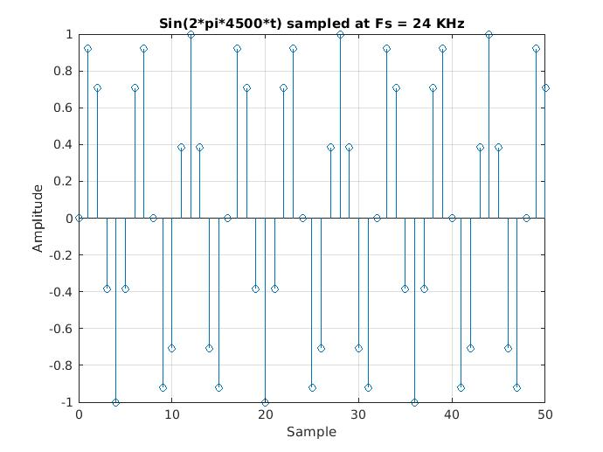

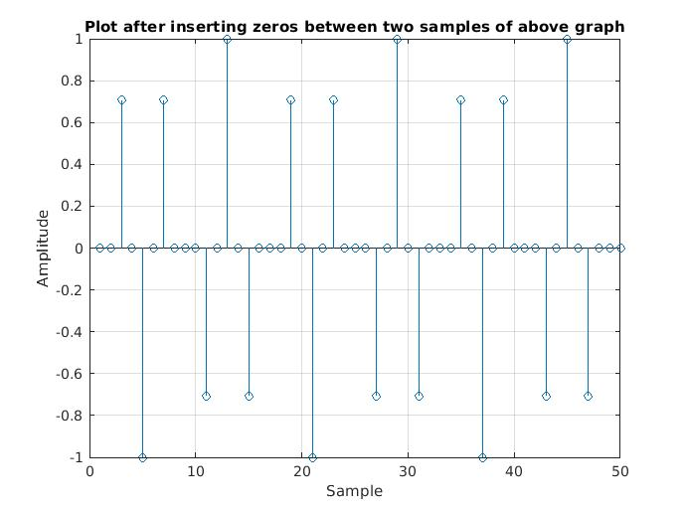

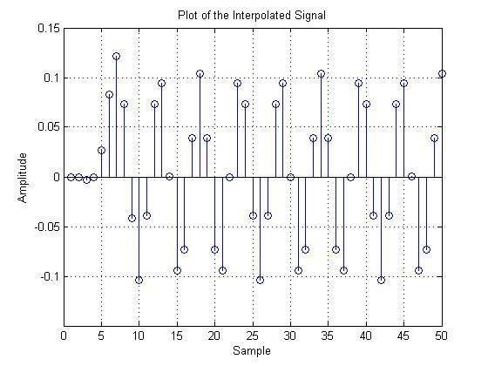

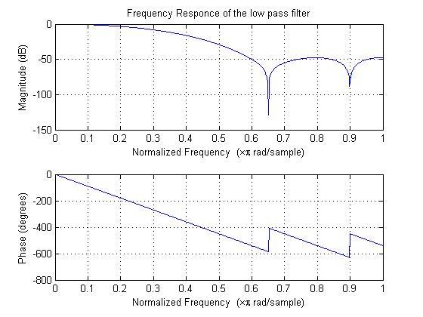

DISCUSSION :

1. To reconstruct an analog signal without losing any energry, the sampling rate should be greater than the double of Bandwidth.

2. For continuous signals, if X(f) is the Fourier Transform of x(t), then 1/k × X(f/k) is the Fourier Transform of x(kt), where k is the parameter controlling the expansion or contraction. Explaining it physically if an event happens faster (it is compressed in time) it must be composed of higher frequencies. Similarly if an event happens slower (it is expanded in time), it must be composed of lower frequencies.

3.If the signal contains no sinusoidal components with frequencies higher than half the sampling frequency, then there will be no aliasing distortion.However, The phenomenon of aliasing can be removed by passing the signal through a band pass filter with cutoff frequency half of the sampling rate. This way also we will be losing some information but the amount of information lost will be lesser than that caused by overlapping.

4. Upsampling gives better representation of the analog signal when reconstructed than the original one as it has more information content. In this experiment we did zero order up sampling. To approximate it better we can do higher order upsampling like the padded signal to be average of the adjacent samples or equal to the previous sample. These techniques would return better signal upon reconstruction.